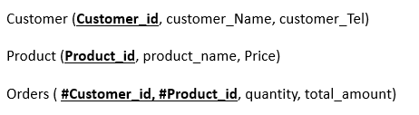
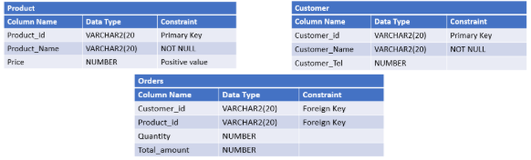
- You are asked to create the above given relational model using SQL language and based on the different mentioned constraints:

CREATE TABLE Customer (
Customer_ID VARCHAR(20),
Customer_Name VARCHAR (20) NOT NULL,
Customer_tel NUMBER,
PRIMARY KEY (Customer_ID)
);
CREATE TABLE PRODUCT (
PRODUCT_ID varchar(20),
PRODUCT_Name varchar(20) NOT NULL,
Price NUMBER,
PRIMARY KEY (PRODUCT_ID)
);
CREATE TABLE Orders (
Customer_ID VARCHAR(20),
PRODUCT_ID varchar(20),
Quantity NUMBER,
Price NUMBER,
FOREIGN KEY (Customer_ID) REFERENCES Persons(Customer_ID),
FOREIGN KEY (PRODUCT_ID) REFERENCES Persons(PRODUCT_ID)
);
After creating tables, write SQL commands to:
- Add a column Category (VARCHAR2(20)) to the PRODUCT table.
- Add a column OrderDate (DATE) to the ORDERS table which have SYSDATE as a default value.

ALTER TABLE PRODUCT
ADD Category varchar(20);

ALTER TABLE OrderDate
ALTER OrderDate SET DEFAULT SYSDATE();

